# To Do List - jQuery

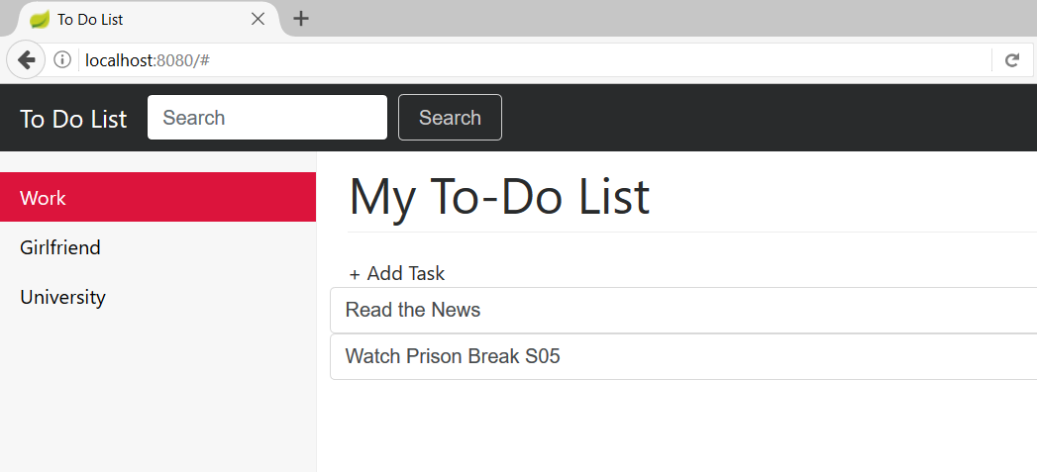

Build **RESTful** Web Services with **Spring Boot**. Crate an application that consumes **JSON** via **AJAX** and **jQuery**.

## Create the Design

Create a **single** page that will handle all the **operaions** in your **app**. You can create your own design. However, if you want to create something like in the picture use this [Bootstrap 4 reference](https://v4-alpha.getbootstrap.com/examples/dashboard/). Here is an overview of the required elements:

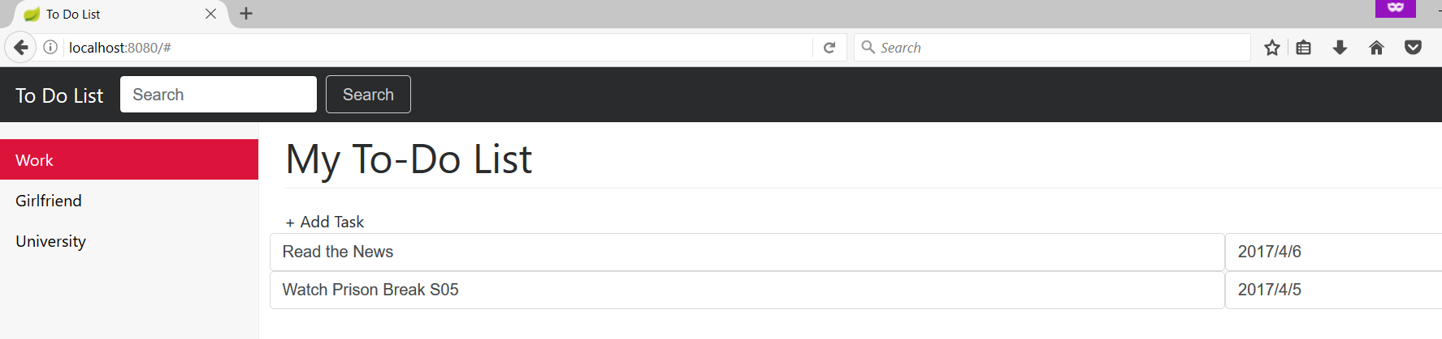

* Search menu on the top
* Categories menu on the right
* Add Task link
* To-Do Items

## Create the Entities

You will need two entities.

**ToDoItem:**

* **Id**
* **Name**
* **Deadline**
* **Is Enabled**
* **Category**

**Category:**

* **Id**
* **Name**

## Create the Necessary Repositories

## Create the Necessary Services

## Create the Necessary Controllers

## Load Categories

Use **AJAX** to load the categories in the database. If you don’t have any add **manually** some. Use **GET** request.



## Add To-Do Item

When **+AddTask** is **clicked** a small should appear. When you enter data send **POST** request via **AJAX**. When you click “**Save**” send the request. When you click “**Cancel**” **hide** the inputs.

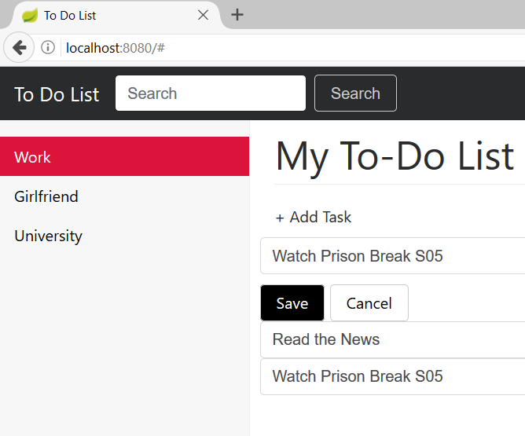

## Update To-Do Item

When you hit “**ENTER**” and **change** the **data** of some of the existing items send a **PUT** request to make the update. Use “**change**” event to achieve that.

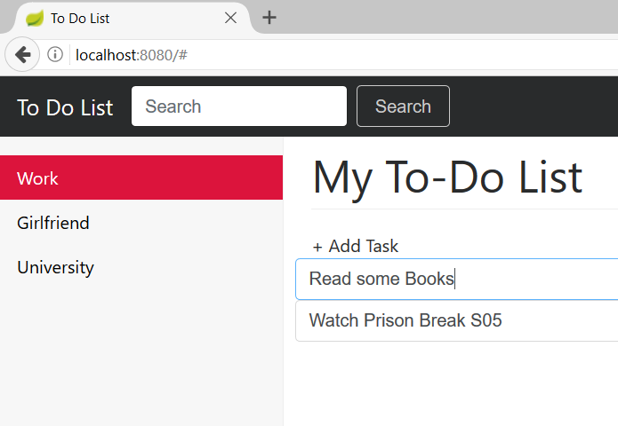

## Delete To-Do Item

When you hit “**ESC**” **delete** the current item. The “ESC” key is with id 27. Send a **DELETE** request.

## Show Items by Category

When you click some of the **categories** show the **items** in that category. Send **GET** request.

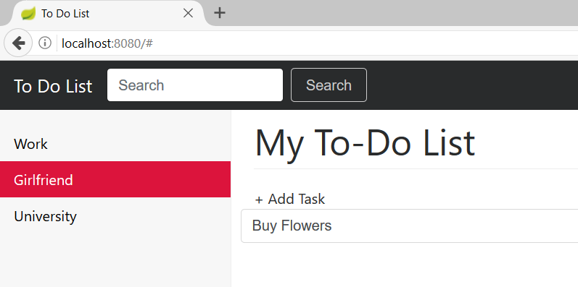

## *Implement Dynamic Search

When you **write** in the **search box** do dynamic search by item **name** and **category**. If you hit “**Search**” do the same thing. Send dynamically **GET** requests.

